Student’s name | …………………………………………………….…… | Grade | 3
Subject | Computer | Week No. | 2
Lesson Title | Inside a Computer | Unit
Worksheet No. ( 2 )

Instruction: Match the following

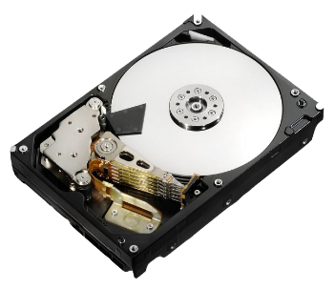 | CPU
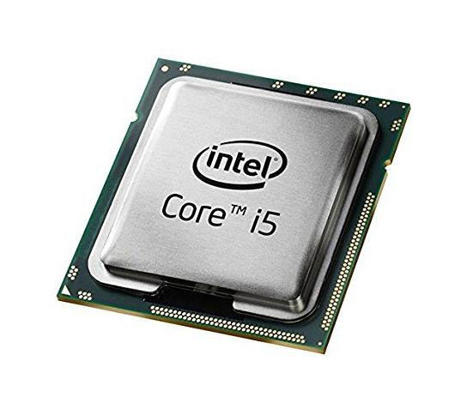 | Hard Disk
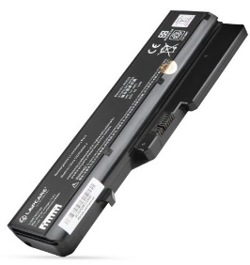 | RAM
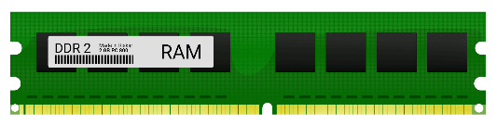 | Battery Laptop

Good Luck

